Beta Test

Mai Yang Xiong, Jun Cai, Mengzhe Wang, Jon Leonardo Rodriguez

1. How was the beta test conducted (Survey? Observation? Interview?..... Provide instruments if applicable)?
The beta test was conducted in a 59 minutes, face-to-face, class period, during school hours. It was conducted using the Ticket-Out the door assessment and the Student Electronic Evaluation of the lesson. The Ticket-Out the Door assessment, see Appendix D in Appendices Folder, was given to check for student understanding of the lesson. It consisted of a problem that was very basic and not too complex due to time constraint, which required the students to find a formula for the area of the cross section, find the limits of integration, and integrate the area to find the volume. Students were allowed to use their graphing calculator and the online dynamic mathematics software (Geogebra).
After completion of the Ticket-Out the door, the Student Electronic Evaluation (see the link below) was given. Students responded to the eleven Likert-type items and one open-ended question. The students took the evaluation using their chromebook.
- Student Electronic Evaluation: http://goo.gl/forms/72S9zWIhkA
2. Who were involved in the beta test? (# of people and their roles, e.g., target audience, colleagues…)
The beta test involved eleven AP Calculus AB high school students and Ms. X, the instructor. The students have the prerequisite skills, such as differentiating, integrating indefinite and definite integrals, and finding areas between curves. These students have never been exposed to using definite integrals to find the Volume of Solids with known cross sections and this is their first time being exposed to the topic and the lesson.
3. List results
- The beta test informed us that 1 day was not enough for the lesson because within a 59 minutes class period, the instructor was only able to cover up to example 2 in the handout. Students needed more time to process the information from the lesson and practice.
- One student reported that there was 1 mistake in example 2’s diagram on the handout. The diagram showed that the interval was from 0 to 1. It should be from 0 to 2.
- During the lesson, the instructor discovered that there was a typing error in the Ticket-Out the Door assessment. In the stem of the question, the function 𝑓was missing from its equation.
- After grading students’ work on the Ticket-Out the Door assessment, see Table 1, we learned the average score was 1.91 points, which was very close to a 2. Based on our 3-point Rubric, see Appendix F in Appendices Folder, a score of a 2 implied that the students wrote a definite integral for the volume of a solid, with known cross, and integrate it to find the volume with minimal errors.
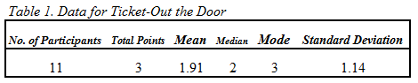
- After examining student’s work on the Ticket-Out the Door assessment, see Table 2, it also revealed that only half of the students were able to write a definite integral for the volume of the solid, with known cross section, and integrate it to find the volume without any error. The other half of the students wrote an incorrect formula for$A(x)$, the area of the cross section. The students were using either the area formula of a square or triangle instead of a rectangle (the required cross section) for $A\left(x\right).$ Overall, 8 students (73%) were able to evaluate definite integrals, 2 students (18%) did not integrate their written definite integral, and 1 student (9%) who did not integrate due to not having a definite integral written.
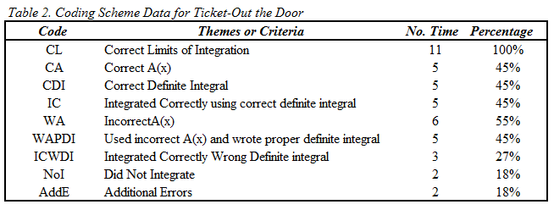
- Question 1-10, see Appendix A: A Summary of Student Evaluation Responses, were Likert-type rating items and students had to rank the items strongly agree, agree, neutral, disagree, or strongly disagree (which corresponded to 1 through 5). Based on students’ evaluation, Question 1-10, see Student Electron Evaluation, the majority of students ranked the Likert-type items as either 1:strongly agree or 2:agree. The only item, that was ranked 4:disagree and 5:strongly disagree was Question 5, Online dynamic mathematics software (Geogebra) was useful. One of the two students who gave this ranking stated in Question 12, Do you have any suggestion on how this lesson can be improve?, that “the website lagged.” The school Wi-Fi was slow on the day the beta test was administered, thus causing technical difficulty.
- The overall rating for the lesson in Question 11, see Appendix A: A Summary of Student Evaluation Responses, was a Likert-type item and students had to rank the item as outstanding, excellent, good, fair, or poor (which corresponded to 1 through 5, respectively). The average rating for the overall lesson was about 1.5, between outstanding and excellent.
- In Question 12 student was asked an open-ended question about any suggestions they may have for improvement on the lesson. In addition to the comments about technical difficulty with the website, a student commented that, “It would have been nice if an equilateral triangle was given an example as well as to provide the student with another valuable example for them to learn.”
4. What will you do with the results?
- We will fix the number 1 to 2 on example 2’s diagram in both the Handout and Handout Solution.
- We will add the $f$ to its equation in the Ticket-Out the Door assessment.
- Instead of having the lesson be 1 day (59 minute), we will change the lesson to be a 2-days lesson. Adding 1 additional day will enable the instructor to cover all the examples planned for the lesson. Furthermore, students will have more time to process the information because they will be able ask more questions for clarification and practice the concepts with more examples.
- Adding 1 extra day, will involve adding more examples to the handout for students to practice. Taking into consideration what one student had suggested, the additional examples should incorporate equilateral triangles cross-section.
- Since writing the formula for $A\left(x\right)$ was a weakness for half of the students, when doing example 3 and the additional examples added for day 2 of the lesson, the instructor should check for students’ understanding and written formula at that specific step before
moving onto evaluating the definite integral. We will add this to our Facilitator Guide.
- The Ticket-Out the door showed that students were unsure of the cross section that they were supposed to use. This implies that students had missed that piece of information in the question. Thus, when going over the instruction, the instructor needs to emphasize utilizing reading comprehension strategies such as highlighting, underlining, or circling important information. This strategy needs to also be incorporated into our Facilitator Guide to remind the instructor.

Appendix A: A Summary of Student Evaluation Responses

